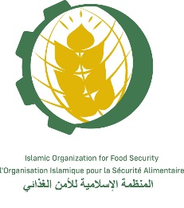
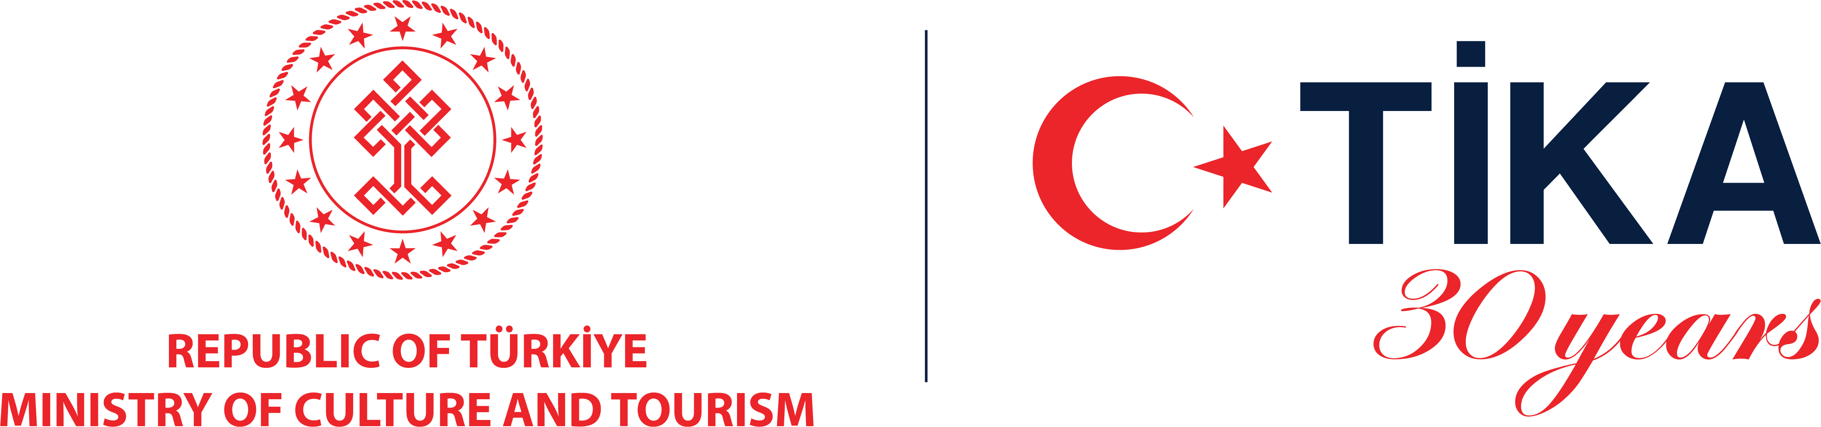


Genetic Resources and Genebank Management
Training course jointly with Seed Gene Bank of Turkiye, Ankara
26 – 30 September 2022

APPLICATION FORM

Personal Information
Name:
First name: …………………………………… Middle name: ………………………………… Last name: ………………………………….
Father’s name:
Mother’s Name:
Date of birth:
Gender (M/F):
Nationality :
Address :

Telephone :
E-mail :

Education
Highest degree:
Institution:
Year obtained:
Major subjects :
Previous training courses attended in the field of Genetic Resources Conservation (Title/year)
……………………………………………………………………………………………………………………………………………………………………………………………………………………………………………………………………………………………………………………………………………………………………………………………………………………………………………………………………………………………………………………………………………………………………………………………………………………………………………………………………………………………………………………………………………………………………………………………………………………………………………………………………………………………………………………………………………………………………………………………………………………………………………………………………………………………………………………………………………………………………………………………………………………………………………………………………………………………………………..
Employment
Current position :
Employer:
Years on the job:
Address:

Description of research responsibilities and expectations from the course

Languages
Native language:
Spoken and written English language skills

Excellent Good Fair Poor
Spoken and written French language skills

Excellent Good Fair Poor

* Proficiency in French is essential to follow lectures and to participate in discussions

NOMINATING AGENCY

Official in Charge
Name :
Position :

Agency
Name of agency:
Address:
Telephone :
Fax :
E-mail:

DOCUMENTS to be SUBMITTED

- Application form signed
- Curriculum Vitae
- Scanned copy of your passport and photo

THE APPLICATION CAN ONLY BE ACCEPTED IF ALL DOCUMENTS ARE SUBMITTED

Signed:

Date:

Signature of Supervisor:

The completed application form, curriculum vitae and scanned copy of your passport should be received by IOFS
before 10 September 2022
Please send them to the attention of
Mrs. Makpal Bulatova
Program Manager, IOFS, E-mail: m.bulatova@iofs.org.kz

