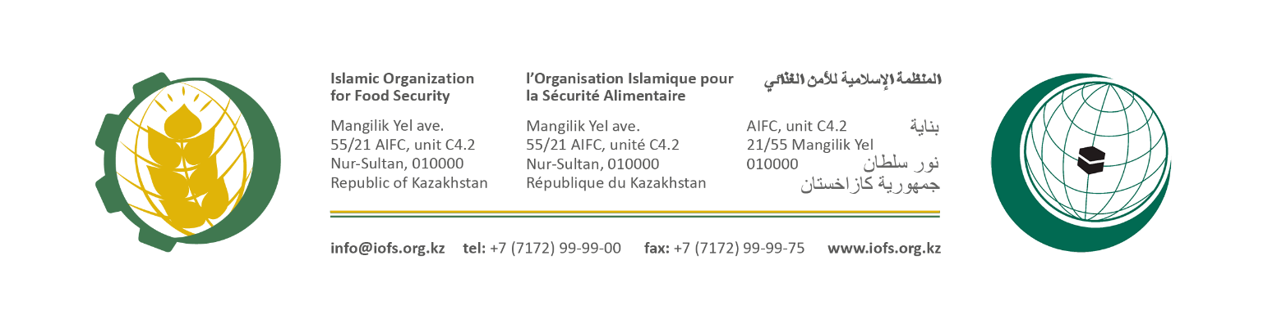
Concept note
Grain Fund
Introduction

Food security is a complex and multifaceted issue that along with physical and economic accessibility, raises issues of food self-sufficiency and minimizing food price fluctuations. The wide spread of the pandemic of COVID-19 through this year, has affected all spheres of public life, and extended to harm the state of food security in the world and individual countries. According to international experts, the pandemic creates risks of a critical increase in the number of hunger and malnutrition by the end of 2020.
The food security aspects have been influenced by the shortage of food availability internationally and consequently in OIC/IOFS Member States (MS). The ongoing situation requires the consolidation of all efforts in the Muslim World.
The Second meeting of the IOFS General Assembly, held in Jeddah (Kingdom of Saudi Arabia, August 2019) has adopted the Resolution IOFS / GA / 1-13-2019 which provides the commence of establishing a Grain Fund to ensure food security. This resolution also has addressed to the Islamic Development Bank and other relevant financial, investment institutions that would assist to execute the Grain Fund.
The Grain Fund aims to create a sustainable system to address the following key objectives:
- Reducing dependency on the world agricultural and food markets and vulnerability to the fluctuations of world prices by enhancing intra - OIC capacities;
- Increase in the volume of agricultural production and unified food market in the OIC member states;
- The ability to mitigate adverse impacts through compensation for damage;
- Provision of international humanitarian aid to OIC countries in dire need.

The proposed scheme of the Grain Fund

The Grain Fund will operate on the Islamic Takaful insurance scheme by using the waqf model. At the same time, the scheme of the Grain Fund is supplemented with an investment account/company for generating profit from financial activities.

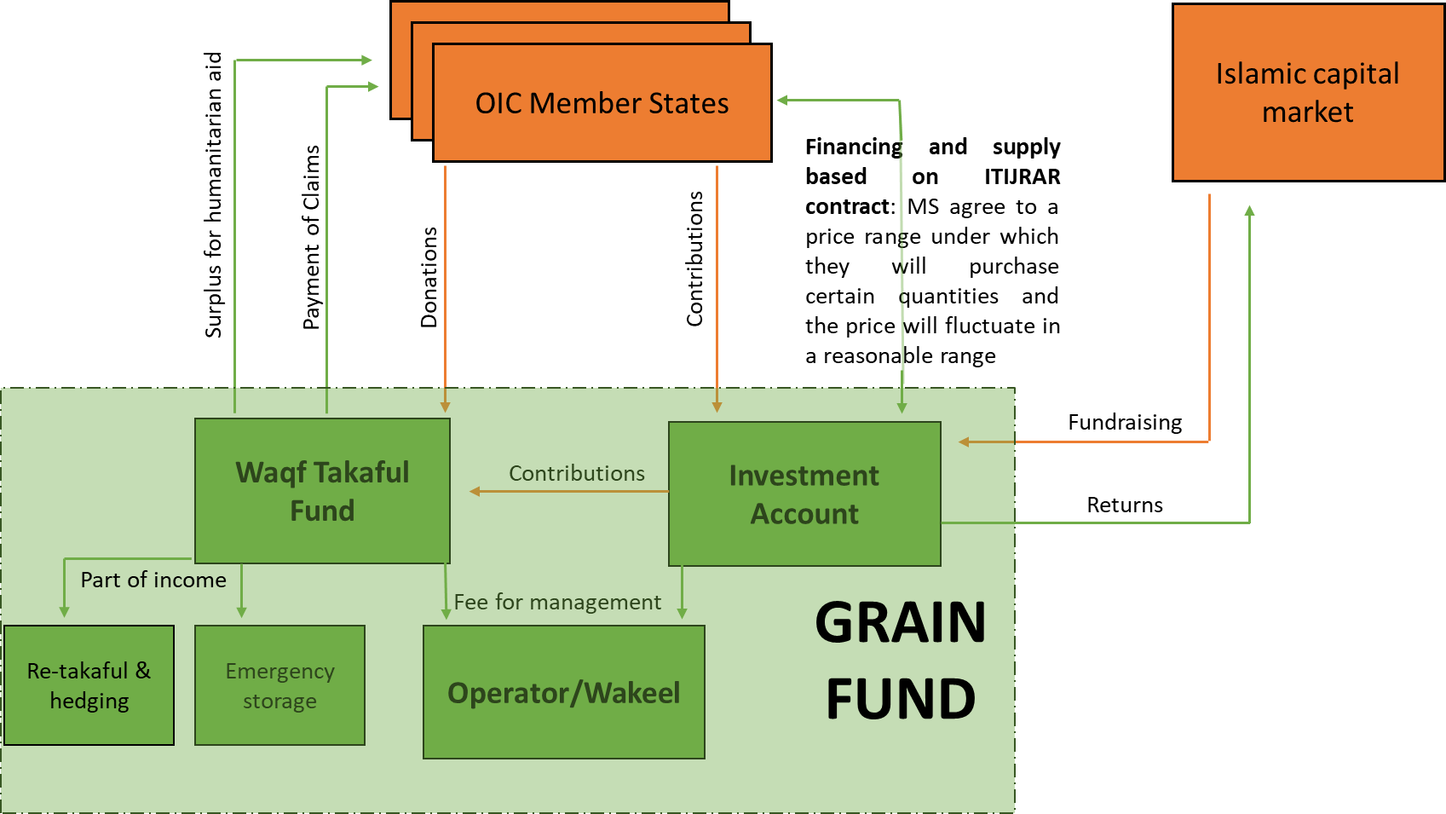

- Сontributions from OIC member states, as well as attracting funds from the Islamic capital market are formatting the Investment Account of the Grain Fund.
- Investment Account of the Grain Fund concludes a contract with the member states: cash-rich MS will order and crop-rich MS will deliver grains within a fixed price range (Istijrar concept which is a price range under which they will purchase certain quantities of crops and the price will fluctuate in a reasonable range, not excessive pricing and not to the detriment of producers). The Grain Fund should receive a reasonable profit from this activity.
- Investment Account along with MS should donate to an Emergency fund (Waqf Fund) with cash or in-kind resources to be agreed and held ready in storage and in financial reserves to increase flexibility. Part of the funds can be utilized in Islamic hedging tools, or Re-Takaful to improve the catastrophe payout.
- The financial resources of the Waqf Fund shall be utilized to facilitate the business and any additional financial resource shall be managed by IsDB treasury. The Profit from this activity shall flow back to the Waqf Fund. The cash-rich countries diversify their food security strategy with their participation within the Muslim Ummah.
The surplus (beyond emergency reserves) of Waqf Fund will be distributed between the participating MS, as well as Grain Fund for capacity building and for humanitarian purposes.
The concept shall create mutual benefits for all types of member states.

The Secretariat
Islamic Organisation for Food Security
Nur Sultan, Republic of Kazakhstan

The Grain Fund is a conventional name, the activities of this fund will cover not only grain crops, but the main types of food produced and consumed in the OIC countries

