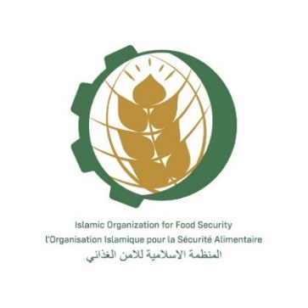
Tentative program of the meeting
Nur-Sultan, Kazakhstan, (on-line)
(November 29, 2021 – 4 p.m.)

TIME ZONE of Nur Sultan, KAZAKHSTAN

Moderator: Dr. Ismail Abdelhamid, the IOFS Secretariat Director of Programmes & Projects Office

4 pm | Recitation of Verses from Holy Quran
4:05 pm | Opening Address - Director General IOFS H.E. Mr. Yerlan Baidaulet
4:10 pm | Рresentation and overview of the proposed Grain Fund structure by Strategic Insights
4:40 pm | Open discussion
5:10 pm | Closing session – Dr. Ismail Abdelhamid

