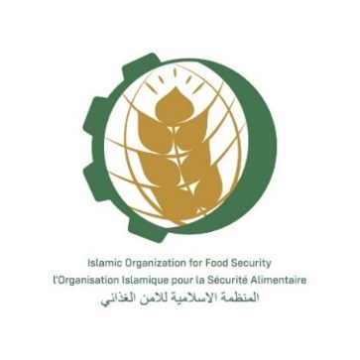
DRAFT
Virtual Consultative Meeting
«Creation the Regional Food Security Reserve”
Nur-Sultan, Kazakhstan, (on-line)
(December 6th 2021 – 3 p.m.)

TIME ZONE of Nur Sultan, KAZAKHSTAN

Moderator: Dr. Ismail Abdelhamid, the IOFS Secretariat Director of Programmes & Projects Office
Topic: The Regional Food Security Reserve (RegFSR) structure, mechanism and its detailed rules and working modalities; recommended type of food and it’s among for RegFSR; assessment whether or not a separately RegFSR Feasibility Study is required; adoption of the Action Plan for 2022; comments to the Memorandum of Understanding on the creation of Food Security Reserves in the OIC countries; and other relevant issues
15:00 | Recitation of Verses from Holy Quran
15:05 | Opening Address - Director General IOFS H.E. Mr. Yerlan Baidaulet
15:10 | Welcome Address – Guest of Honor (TBC)
15:15 | Introduction, welcome, and outline of the meeting’s agenda and presentation of the IOFS proposal and overview on Regional FSR and MoU by Dr. Ismail Abdelhamid, the IOFS Secretariat Director of Programmes & Projects Office
15:30 | Questions and answers
15:40 | Speech of Afghanistan representative regarding meeting agenda (TBC)
15:50 | Speech of the Islamic Republic of Iran representative regarding meeting agenda (TBC)
16:00 | Speech of the Republic of Tajikistan representative regarding meeting agenda (TBC)
16:10 | Speech of the Republic of Turkey representative regarding meeting agenda (TBC)
16:20 | Speech of the Republic of Kazakhstan representative regarding meeting agenda (TBC)
16:30 | Speech of the Republic of Azerbaijan representative regarding meeting agenda (TBC)
16:40 | Speech of the Republic of Uzbekistan representative regarding meeting agenda (TBC)
16:50 | Speech of the Republic of Albania representative regarding meeting agenda (TBC)
17:00 | Speech of the Turkmenistan representative regarding meeting agenda (TBC)
17.10 | Speech of the Kyrgyz Republic representative regarding meeting agenda (TBC)
17.20 | Open discussion
18.30 | Adoption of the minutes of the meeting, action plan for 2022 – Dr. Ismail Abdelhamid, Director of Programmes & Projects Office, IOFS
18:40 | Closing session – Dr. Ismail Abdelhamid

Working language of the event is English with interpretation into Russian

